**Software Development Cycle Workbook**

Software Development Lifecycle (SDLC)

|  |
| --- |
| Process used by the software industry to produce high quality systems or exceed customers expectations |

Phases of SDLC

|  |
| --- |
| 1.  Business Analysis , Requirements Analysis |
| 2.  Design |
| 3.  Development |
| 4.  Testing |
| 5.Deployment |
| 6.  Maintenance |

|  |  |
| --- | --- |
| **1A— Business**  **Analysis** | Identify the current state – where are we now? Understanding the current state allows us to identify the needs that need to be fulfilled by our project |
| **1B— Requirements Analysis** | Second half of analysis – requirements analysis or requirements gathering |
| **2— Design** | High-Level Design (HLD) - lists the functional aspects of the various modules, along with the final result.  Low-Level Design (LLD) - details the logic and execution of each module in an HLD. |
| **3— Development Coding** | Programming tools like compilers, interpreters, and language such as COBOL, C, C++, and Java are used for coding with respect to the type of application. |
| **4— Testing** | Software Quality is best determined by how well the software meets the requirements. |
| **5— Deployment** | Validating functionality. Know how service will perform in a live environment prior to releasing it into the live environment. |
| **6—Maintenance** | Phase is an ongoing process that includes updates , upgrades, new features , and maintenance of hardware and software. |

|  |  |
| --- | --- |
| High-level Design |  |
| Low-level  Design |  |

|  |  |
| --- | --- |
| User  Experience  Testing |  |
| Functionality Testing |  |
| Security  Testing |  |
| Load  Testing |  |
| Performance Testing |  |
| Compatibility Testing |  |

What is the importance of ensuring users are properly trained?

Making sure they know how to use software effectively

Why does this training need to occur before rollout?

Not having users ready to interact with new system is a major risk to implementation

What is meant by “deploy into the live environment''?

Customers and users can be allowed to begin utilization of the functionality.

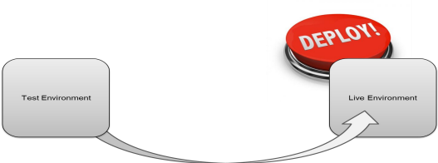

What steps are necessary after deployment into the live environment to allow users to utilize the new functionality?  
  
Maintenance , Updates, Upgrades, New Features.